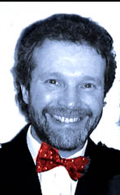
Mr David Marshall
Owner of Car Care’s Garage

